FLASH CARDS

BLOOMS TAXONOMY: REMEMBERING
- Choose 6 of the Netlingo terms below.
- Research the meaning of your words using any of the sites listed below
  - http://www.netlingo.com/index.php
  - http://www.wordnik.com/
  - http://ninjawords.com/
- Create your flash cards using one of the options below.

NETLINGO TERMS
Microblogging
Netbook
Happy Slapping
Mashup
Social networking site/service
Carbon Footprint
Web 2.0 applications
Viral
Word-of-mouse
Meme
Sexting
Drug dump
Digital footprint
Digital doppelganger
Ego-surfing
CrackBerry
Post-PC
Cyber bulling

http://www.netlingo.com/index.php
_____________________________________________________________________________________________
There are various tools online for creating flash cards. You can also create them in Word.

Option 1: http://quizlet.com

Option 2: http://www.flashcardmachine.com/

OPTION 3: http://www.flashcardexchange.com

Option 4: Use Word to create your flash cards.
How to make flash cards using Word
 | Start Word.
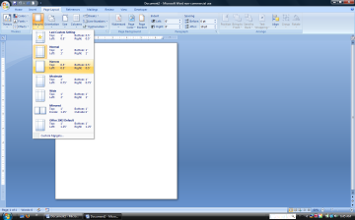 | Change Page Layout to .5 for all margins
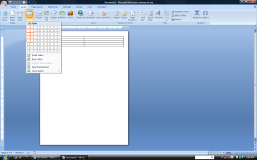 | Insert a table that is 2 columns by 5 rows
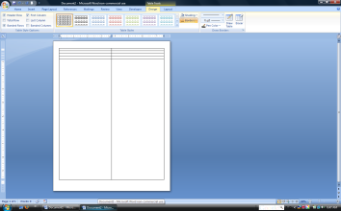 | Put mouse pointer on bottom of table and drag to the bottom of the page. NOTE: You might want to leave a little space otherwise it may create a second page. This you could leave if you wish, but it may add a second page.
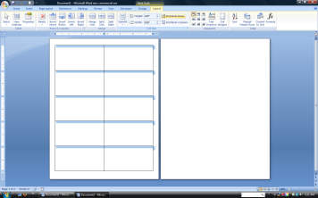 | Now distribute the rows evenly. This will make all of the boxes the same size.
. 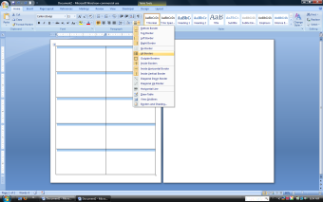 | NOTE: make sure all of the boxes have a border.
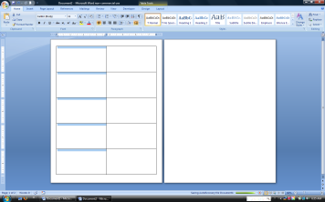 | Put Mouse pointer at the top of the fist column. A little black arrow should appear. Click and you will have selected the first row.
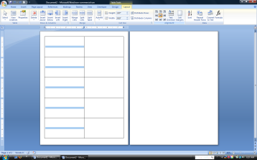 | Now go to alignment under table properties.  Choose Center both vertically and horizontally.
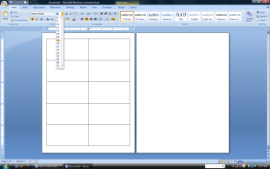 | Now change the Font to Bold and size 16 or 18.  Here you could do something a little different:  - Use pictures  - Use formulas
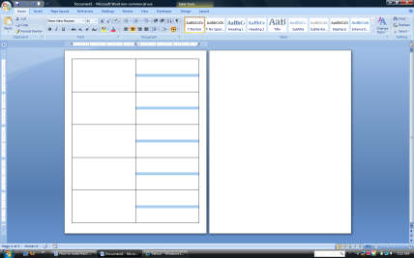 | Now click at the top of the second column to select it and do the following  - Center both vertically and horizontally  - Font should be at Times new Roman size 11 or 12. You need more room to type definitions.
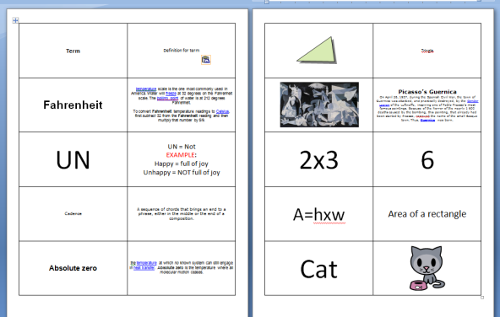 | Here are some examples of ways you can create flashcards.  Please note that sizes of fonts have been changed based on length of word or definition.
 | You may feel the definitions are too close to the edge of the box. You can fix this by click in the definition box and then right mouse clicking.
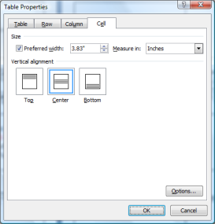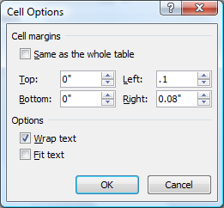 | - Choose table properties  - When the dialogue box appears, choose the Cell tab and click on the option button on the bottom.  - Uncheck box marked same as the whole table and change margin size to .1 or .5.
Now print cards. Fold in half and cut them apart. Staple, tape, or glue the edges together.
SPECIAL NOTE: If you want to use card stock and print on back and front of the card then you can do this same thing only put the terms on one side and the definitions on the other.

When you send it through the printer, print the first side by click on that page and choose print only current page. Put the cardstock back into the printer to print other side. Click on the next page and choose print only current page.

You could do this with multiple pages as well.

